**VirtIO Sound**

**virtio标准**

**前后端**

http://rcore-os.cn/rCore-Tutorial-Book-v3/chapter9/2device-driver-2.html

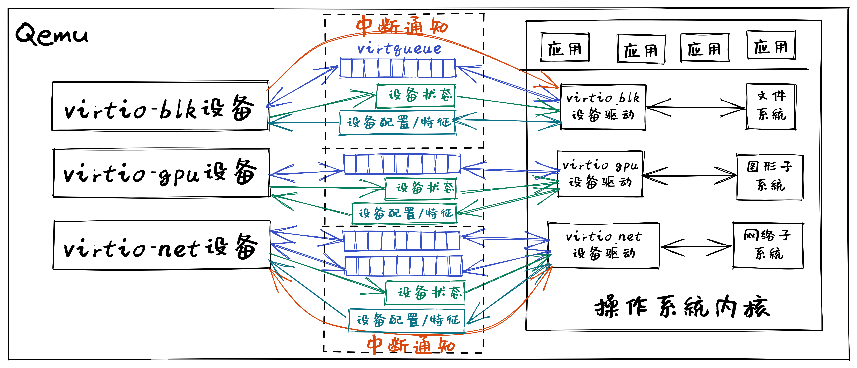

对于guest os来说，需要一个virtio框架负责访问总线获取host支持的virtio device（后端），并通过接口支持virtio driver（前端）对相应virtio device的查找和绑定。

对于guest os中的各种驱动框架，则需要实现一个virtio driver，对于guest来说virtio device的具体实现是不可见的，不需要关心，只需要按照virtio1.2中的标准进行数据交换即可。

**数据交换**

https://ozlabs.org/~rusty/virtio-spec/virtio-paper.pdf

前后端交互的数据结构是vring/vqueue，其中有三个主要部分：

* descriptor entry：这里每个entry都记录了一段gpa（Guest Physical Address）内存，available ring和used ring会用index引用这里的entry。
* available ring：待host处理的entry；由guest添加，host读取。
* used ring：host处理完的entry，会记录处理的长度；由host添加，guest读取。

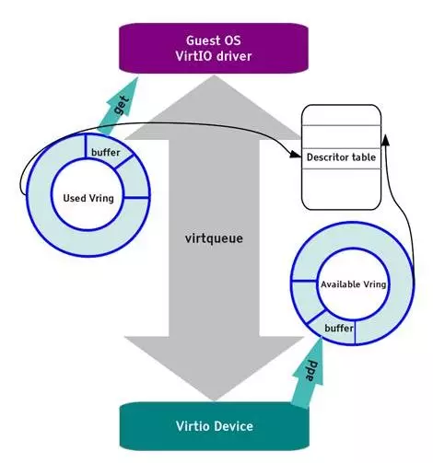

virtqueue有下面几个标准ops：

* add_buf：向available ring添加gpa buffer；
* kick：添加完buffer后提醒host可以开始进行处理；
* get_buf：从used ring获取一个处理后的buffer；
* disable_cb：关闭提醒，不再关心host是否处理了buffer；
* enable_cb：打开提醒。

|  |
| --- |
| C struct virtqueue_ops {  int (*add_buf)(struct virtqueue *vq, struct scatterlist sg[],  unsigned int out_num, unsigned int in_num, void *data);  void (*kick)(struct virtqueue *vq);  void *(*get_buf)(struct virtqueue *vq, unsigned int *len);  void (*disable_cb)(struct virtqueue *vq);  bool (*enable_cb)(struct virtqueue *vq);  }; |

* *关于struct scatterlist：由于gva(Guest Virtual Address)对应的gpa通常是一堆零散的内存，所以Linux中使用“散列表”的数据结构把这些零散的内存串在一起使用。*
* *关于disable/enable cb：一般是在notify_cb中，伴随着开关中断来使用的。*

**sound device**

https://docs.oasis-open.org/virtio/virtio/v1.2/virtio-v1.2.html

在virtio标准中，每种设备都定义了一套标准，规定了virtqueue的数量和功能，以及buffer传输的其他细节，这里我们只讨论sound device，下面简略介绍一下。

**4个virtqueue**

* controlq：用于guest向host发送控制信息。
* eventq：host向guest报告事件。
* tx：播放pcm，由guest提供pcm buffer。
* rx：录制pcm，由guest提供空白buffer，host填充。

**3种控制信息**

control message和event 都有公共的header，其成员是一个le32 code用于标识控制信息内容：

* jack：后端外接设备的查询和选择。
* pcm：start/stop/set_param等播放控制。
* channel map：通道格式的配置。

|  |
| --- |
| C  /* jack control request types */   VIRTIO_SND_R_JACK_INFO = 1,   VIRTIO_SND_R_JACK_REMAP,     /* PCM control request types */   VIRTIO_SND_R_PCM_INFO = 0x0100,   VIRTIO_SND_R_PCM_SET_PARAMS,   VIRTIO_SND_R_PCM_PREPARE,   VIRTIO_SND_R_PCM_RELEASE,   VIRTIO_SND_R_PCM_START,   VIRTIO_SND_R_PCM_STOP,     /* channel map control request types */   VIRTIO_SND_R_CHMAP_INFO = 0x0200, |

**2种事件**

* jack：连接和断开的通知。
* pcm：播放进度、播放下溢/录制上溢的通知。

|  |
| --- |
| C  /* jack event types */   VIRTIO_SND_EVT_JACK_CONNECTED = 0x1000,   VIRTIO_SND_EVT_JACK_DISCONNECTED,     /* PCM event types */   VIRTIO_SND_EVT_PCM_PERIOD_ELAPSED = 0x1100,   VIRTIO_SND_EVT_PCM_XRUN, |

**Linux virtio sound调研**

**Linux virtio sound流程**

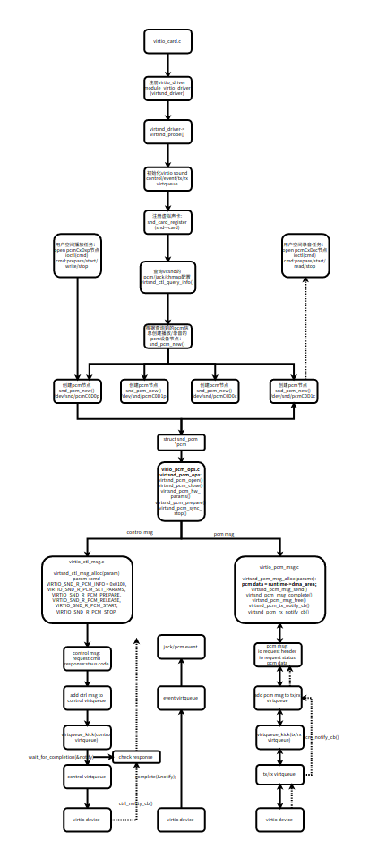

https://github.com/torvalds/linux/tree/master/sound/virtio

|  |
| --- |
| Bash // 向上对接alsa virtio_card.c // 注册为alsa的一张声卡 virtio_pcm_ops.c // 注册alsa中的pcm_ops  // 向下对接virtio virtio_ctl_msg.c // controlq的通用操作 virtio_pcm_msg.c // txq和rxq的通用操作  virtio_chmap.c // 通道格式相关控制和事件处理 virtio_jack.c // 设备选择相关控制和事件处理 virtio_pcm.c // 数据相关控制和事件处理 |

**初始化virtqueue**

初始化virtio audio需要支持的control/event/tx/rx的virtqueue

|  |
| --- |
| C static vq_callback_t *callbacks[VIRTIO_SND_VQ_MAX] = {  [VIRTIO_SND_VQ_CONTROL] = virtsnd_ctl_notify_cb,  [VIRTIO_SND_VQ_EVENT] = virtsnd_event_notify_cb,  [VIRTIO_SND_VQ_TX] = virtsnd_pcm_tx_notify_cb,  [VIRTIO_SND_VQ_RX] = virtsnd_pcm_rx_notify_cb  }; static const char *names[VIRTIO_SND_VQ_MAX] = {  [VIRTIO_SND_VQ_CONTROL] = "virtsnd-ctl",  [VIRTIO_SND_VQ_EVENT] = "virtsnd-event",  [VIRTIO_SND_VQ_TX] = "virtsnd-tx",  [VIRTIO_SND_VQ_RX] = "virtsnd-rx"  }; rc = virtio_find_vqs(vdev, VIRTIO_SND_VQ_MAX, vqs, callbacks, names,  NULL); for (i = 0; i < VIRTIO_SND_VQ_MAX; ++i)  snd->queues[i].vqueue = vqs[i]; |

**get virtio device capability**

设备相关的信息需要从virtio_device结构体中获取，这里需要virtio框架相应的接口支持。

主要是通过向virtio device发送VIRTIO_SND_R_JACK_INFO/VIRTIO_SND_R_PCM_INFO/VIRTIO_SND_R_CHMAP_INFO来查询virtio_device所支持的jack/pcm/chmap信息:

|  |
| --- |
| C /* LE (e.g. modern) Config space accessors. */ #define virtio_cread_le(vdev, structname, member, ptr)  int virtsnd_jack_parse_cfg(struct virtio_snd *snd) {  struct virtio_device *vdev = snd->vdev;  struct virtio_snd_jack_info *info;  u32 i;  int rc;   virtio_cread_le(vdev, struct virtio_snd_config, jacks, &snd->njacks);  if (!snd->njacks)  return 0;  ...  rc = virtsnd_ctl_query_info(snd, **VIRTIO_SND_R_JACK_INFO**, 0, snd->njacks,  sizeof(*info), info); } |

查询pcm返回信息结构如下：

|  |
| --- |
| C struct virtio_snd_pcm_info {   struct virtio_snd_info hdr;   le32 features; /* 1 << VIRTIO_SND_PCM_F_XXX */   le64 formats; /* 1 << VIRTIO_SND_PCM_FMT_XXX */   le64 rates; /* 1 << VIRTIO_SND_PCM_RATE_XXX */   u8 direction;   u8 channels_min;   u8 channels_max;   u8 padding[5];   }; |

**Virtio audio ctl msg**

主要用于向virtio_device发送以下jack/pcm/chmap control msg cmd：

|  |
| --- |
| C enum { // **ctrl msg cmd** /* jack control request types */   **VIRTIO_SND_R_JACK_INFO = 1,**   **VIRTIO_SND_R_JACK_REMAP,**   /* PCM control request types */   **VIRTIO_SND_R_PCM_INFO = 0x0100,**   **VIRTIO_SND_R_PCM_SET_PARAMS,**   **VIRTIO_SND_R_PCM_PREPARE,**   **VIRTIO_SND_R_PCM_RELEASE,**   **VIRTIO_SND_R_PCM_START,**   **VIRTIO_SND_R_PCM_STOP,**    /* channel map control request types */   **VIRTIO_SND_R_CHMAP_INFO = 0x0200,**   ......  **//ctrl msg response**  /* common status codes */ **VIRTIO_SND_S_OK = 0x8000,** **VIRTIO_SND_S_BAD_MSG,** **VIRTIO_SND_S_NOT_SUPP,** **VIRTIO_SND_S_IO_ERR**  }; |

Ctrl msg主要分为request和response两部分：

Request:

|  |
| --- |
| C struct virtio_snd_pcm_hdr {  /* VIRTIO_SND_R_PCM_XXX */  /* hdr.code = cmd */  struct virtio_snd_hdr hdr;  /* 0 ... virtio_snd_config::streams - 1 */  __le32 stream_id; }; |

Response:

|  |
| --- |
| C struct virtio_snd_hdr {  /* code对应以上的**ctrl msg response code VIRTIO_SND_S_OK**   __le32 code; }; |

主要通过以下接口来发送ctrl msg，向control virtqueue发送request，然后等待control virtqueue的nofity cb返回response并检验response status:

|  |
| --- |
| C int virtsnd_ctl_msg_send(struct virtio_snd *snd, struct virtio_snd_msg *msg,  struct scatterlist *out_sgs,  struct scatterlist *in_sgs, bool nowait)  {  ......  //发送request  spin_lock_irqsave(&queue->lock, flags);  rc = virtqueue_add_sgs(queue->vqueue, psgs, nouts, nins, msg,  GFP_ATOMIC);  if (!rc) {  notify = virtqueue_kick_prepare(queue->vqueue);   list_add_tail(&msg->list, &snd->ctl_msgs);  }  spin_unlock_irqrestore(&queue->lock, flags);  if (notify)  virtqueue_notify(queue->vqueue);  ......  //等待response并检测code,wait completion在control virtqueue notify cb中被通知  rc = wait_for_completion_interruptible_timeout(&msg->notify, js);  if (rc <= 0) {  if (!rc) {  dev_err(&vdev->dev,  "control message (0x%08x) timeout\n",  le32_to_cpu(request->code));  rc = -ETIMEDOUT;  }   goto on_exit;  }   switch (le32_to_cpu(response->code)) {  case VIRTIO_SND_S_OK:  rc = 0;  break;  case VIRTIO_SND_S_NOT_SUPP:  rc = -EOPNOTSUPP;  break;  case VIRTIO_SND_S_IO_ERR:  rc = -EIO;  break;  default:  rc = -EINVAL;  break;  }   ...... } |

**Virtio audio pcm msg**

Virtio audio pcm msg主要是通过tx/rx virtqueue向virtio_device传输播放/录音的pcm数据，pcm msg的组成由I/O header，pcm data buffer，I/O status三部分组成：

I/O header：stream_id对应的是当前使用的pcm节点的stream

|  |
| --- |
| C struct virtio_snd_pcm_xfer {   le32 stream_id;  }; |

Pcm data buffer：录音/播放的pcm数据

I/O status：

|  |
| --- |
| C struct virtio_snd_pcm_status {  //status同ctrl msg的response的code   le32 status;   //对应传输的pcm data的长度，用于换算成时延，用于更新stream runtime audio data信息  le32 latency_bytes; }; |

在pcm传输前要将传输的pcm数据信息通过**VIRTIO_SND_R_PCM_SET_PARAMS**发送给virtio_device：

|  |
| --- |
| C struct virtio_snd_pcm_set_params {  struct virtio_snd_pcm_hdr hdr; /* .code = VIRTIO_SND_R_PCM_SET_PARAMS */  le32 buffer_bytes;  le32 period_bytes;  le32 features; /* 1 << VIRTIO_SND_PCM_F_XXX */   u8 channels;   u8 format;   u8 rate;   u8 padding;   }; |

每个pcm msg的pcm数据大小为period_bytes。

**pcm流传输流程**

参考https://docs.oasis-open.org/virtio/virtio/v1.2/cs01/virtio-v1.2-cs01.html#x1-52900014

A PCM stream has the following command lifecycle:

1. SET PARAMETERS

The driver negotiates the stream parameters (format, transport, etc) with the device.

Possible valid transitions: set parameters, prepare.

1. PREPARE

The device prepares the stream (allocates resources, etc).

Possible valid transitions: set parameters, prepare, start, release.

Output only: the driver transfers data for pre-buffing.

1. START

The device starts the stream (unmute, putting into running state, etc).

Possible valid transitions: stop.

1. The driver transfers data to/from the stream.
2. STOP

The device stops the stream (mute, putting into non-running state, etc).

Possible valid transitions: start, release.

1. RELEASE

The device releases the stream (frees resources, etc).

Possible valid transitions: set parameters, prepare.

**pcm传输**

|  |
| --- |
| C int virtsnd_pcm_msg_send(struct virtio_pcm_substream *vss) {  struct snd_pcm_runtime *runtime = vss->substream->runtime;  struct virtio_snd *snd = vss->snd;  struct virtio_device *vdev = snd->vdev;  struct virtqueue *vqueue = virtsnd_pcm_queue(vss)->vqueue;  int i;  int n;  bool notify = false;   i = (vss->msg_last_enqueued + 1) % runtime->periods;  n = runtime->periods - vss->msg_count;   // 得到剩余的buffer数量，并全部添加到txq/rxq的available ring上。  for (; n; --n, i = (i + 1) % runtime->periods) {  struct virtio_pcm_msg *msg = vss->msgs[i];  struct scatterlist *psgs[] = {  &msg->sgs[PCM_MSG_SG_XFER],  &msg->sgs[PCM_MSG_SG_DATA],  &msg->sgs[PCM_MSG_SG_STATUS]  };  int rc;   msg->xfer.stream_id = cpu_to_le32(vss->sid);  memset(&msg->status, 0, sizeof(msg->status));   if (vss->direction == SNDRV_PCM_STREAM_PLAYBACK)  rc = virtqueue_add_sgs(vqueue, psgs, 2, 1, msg,  GFP_ATOMIC);  else  rc = virtqueue_add_sgs(vqueue, psgs, 1, 2, msg,  GFP_ATOMIC);   if (rc) {  dev_err(&vdev->dev,  "SID %u: failed to send I/O message\n",  vss->sid);  return rc;  }   vss->msg_last_enqueued = i;  vss->msg_count++;  }   // 通知host开始处理数据  if (!(vss->features & (1U << VIRTIO_SND_PCM_F_MSG_POLLING)))  notify = virtqueue_kick_prepare(vqueue);   if (notify)  virtqueue_notify(vqueue);   return 0; } |

**pcm传输完成**

这里是txq和rxq使用的notify_cb，关中断并处理所有已经播放/录制的buffer，这种写法也可以简单地扩展到eventq的事件处理函数上。

|  |
| --- |
| C static inline void virtsnd_pcm_notify_cb(struct virtio_snd_queue *queue) {  struct virtio_pcm_msg *msg;  u32 written_bytes;  unsigned long flags;   spin_lock_irqsave(&queue->lock, flags);  do {  virtqueue_disable_cb(queue->vqueue);  while ((msg = virtqueue_get_buf(queue->vqueue, &written_bytes)))  virtsnd_pcm_msg_complete(msg, written_bytes);  if (unlikely(virtqueue_is_broken(queue->vqueue)))  break;  } while (!virtqueue_enable_cb(queue->vqueue));  spin_unlock_irqrestore(&queue->lock, flags); } |

**Vela virtio sound**

**架构图**

由guest上的virtio framework访问总线注册virtio设备，并向上提供接口支持virtio驱动与virtio设备绑定在一起；对于guest的各驱动框架来说，则需要基于virtio driver标准实现一个lowerhalf。

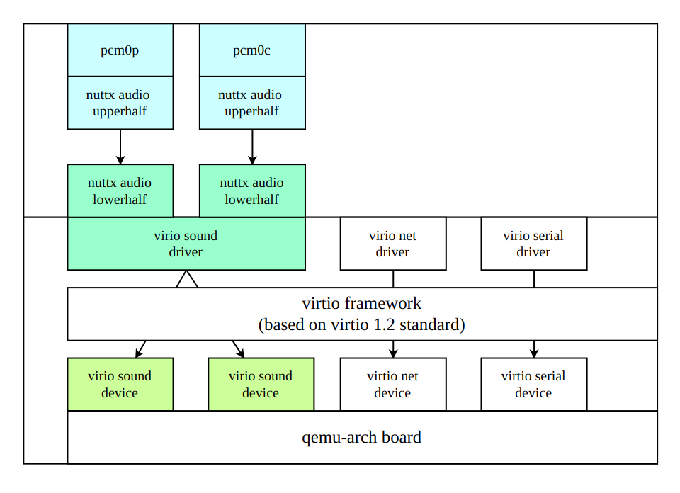

**Vela virtio sound driver主要流程**

**1）构建并注册一个virtio driver:**

|  |
| --- |
| C static struct virtio_driver g_virtio_audio_driver = {  LIST_INITIAL_VALUE(g_virtio_audio_driver .node), /* node */  VIRTIO_ID_SOUND, /* device id */  virtio_audio_probe, /* probe */  virtio_audio_remove, /* remove */ }; virtio_register_driver(&g_virtio_audio_driver); |

注册完之后会进入到virtio_audio_probe()

**2）初始化virtio device**

**初始化control/event/tx/rx virtqueue**

|  |
| --- |
| C static vq_callback_t *callbacks[VIRTIO_SND_VQ_MAX] = {  [VIRTIO_SND_VQ_CONTROL] = virtsnd_ctl_notify_cb,  [VIRTIO_SND_VQ_EVENT] = virtsnd_event_notify_cb,  [VIRTIO_SND_VQ_TX] = virtsnd_pcm_tx_notify_cb,  [VIRTIO_SND_VQ_RX] = virtsnd_pcm_rx_notify_cb  }; static const char *audio_virqueue_names[VIRTIO_SND_VQ_MAX] = {  [VIRTIO_SND_VQ_CONTROL] = "virtsnd-ctl",  [VIRTIO_SND_VQ_EVENT] = "virtsnd-event",  [VIRTIO_SND_VQ_TX] = "virtsnd-tx",  [VIRTIO_SND_VQ_RX] = "virtsnd-rx"  }; virtio_create_virtqueues(vdev, 0, VIRTIO_SND_VQ_RX, audio_virqueue_names,  callbacks); |

**设置virtio device status**

|  |
| --- |
| C virtio_set_status(vdev, VIRTIO_CONFIG_STATUS_DRIVER_OK); |

**填充空buffer到event virtqueue**

参考https://docs.oasis-open.org/virtio/virtio/v1.2/cs01/virtio-v1.2-cs01.html#x1-52900014

**查询pcm/chmap/jack信息**

|  |
| --- |
| C rc = virtsnd_ctl_query_info(snd, VIRTIO_SND_R_PCM_INFO, 0,  snd->nsubstreams, sizeof(*info), info); |

主要是获取virtio_device支持substream的feature/format/rate/channel/direction等信息，其中direction为VIRTIO_SND_D_OUTPUT就是播放流，为VIRTIO_SND_D_INPUT则是录音流。

**注册Vela声卡**

根据查询到的pcm/chmap substream信息来注册Vela声卡，每个substream注册1个Vela pcm设备，生成播放的/dev/audio/pcmxp或者录音的/dev/audio/pcmxc设备节点，初始化lower half driver的ops并关联uper half driver。

|  |
| --- |
| C #根据substream的direction来注册pcmxp/pcmxc节点 #初始化lower half ops接口集合。 virtio_audio->ops = virtio_audio_ops; audio_register(devname, virtio_audio); |

**3）构建并初始化lower half driver的ops virtio_audio_ops**

|  |
| --- |
| C static const struct audio_ops_s virtio_audio_ops= {  virtio_aud_getcaps, /* getcaps */  virtio_aud_configure, /* configure */  virtio_aud_shutdown, /* shutdown */  virtio_aud_start, /* start */ #ifndef CONFIG_AUDIO_EXCLUDE_STOP  virtio_aud_stop, /* stop */ #endif #ifndef CONFIG_AUDIO_EXCLUDE_PAUSE_RESUME  virtio_aud_pause, /* pause */  virtio_aud_resume, /* resume */ #endif  NULL, /* allocbuffer */  NULL, /* freebuffer */  virtio_aud_enqueuebuffer, /* enqueue_buffer */  virtio_aud_cancelbuffer, /* cancel_buffer */  virtio_aud_ioctl, /* ioctl */  virtio_aud_read, /* read */  virtio_aud_write, /* write */  virtio_aud_reserve, /* reserve */  virtio_aud_release /* release */ }; |

virtio_audio_ops接口集合是重点，对标Linux virtio sound driver当中的virtsnd_pcm_ops，

比如virtio_aud_getcaps可返回查询到的pcm/chmap/jack信息。

virtio_aud_configure实现stream流的param配置，参考virtsnd_pcm_ops的hw_params()接口。

virtio_aud_start用于通过control virtqueue向virtio_device发送VIRTIO_SND_R_PCM_START cmd。

**4）实现virtio audio ctl msg接口**

用于查询/播放/录音流程中通过control virtqueue向virtio_device发送对应的control request cmd。

其实现可参考linux virtio driver virtio_ctl_msg.c

**5）实现virtio audio pcm msg接口**

用于播放/录音流程中pcm数据的交互，比如播放时从将enqueuebuffer的pcm数据通过tx virtqueue发送给virtio device，录音时从rx virtqueue中获取pcm数据填充到enqueuebuffer中。

其实现可参考linux virtio driver virtio_pcm_msg.c

思考

是否可以考虑实现一个组合节点的lower half driver：

virtio audio ctl msg接口和virtio audio pcm msg接口关联到lower dev，与lower half driver组合起来：

|  |
| --- |
| C //Init audio ctrl msg //Init audio pcm msg // 关联 audio ctrl msg、audio pcm msg、lower ops 到lower dev struct audio_lowerhalf_s *virtio_ctrl_and_pcm = virtio_ctrl_io_initialize(virtio_audio_ctrl, virtio_audio_pcm, &g_virtio_audio_ctrl_pcm.lower); // wrapper a new lower interface as a PCM devices  struct audio_lowerhalf_s *vitio_audio_pcm = pcm_decode_initialize(virtio_ctrl_and_pcm); // 注册声卡 audio_register(devname, vitio_audio_pcm); |

**流程图**

系统启动过程中注册声卡信息

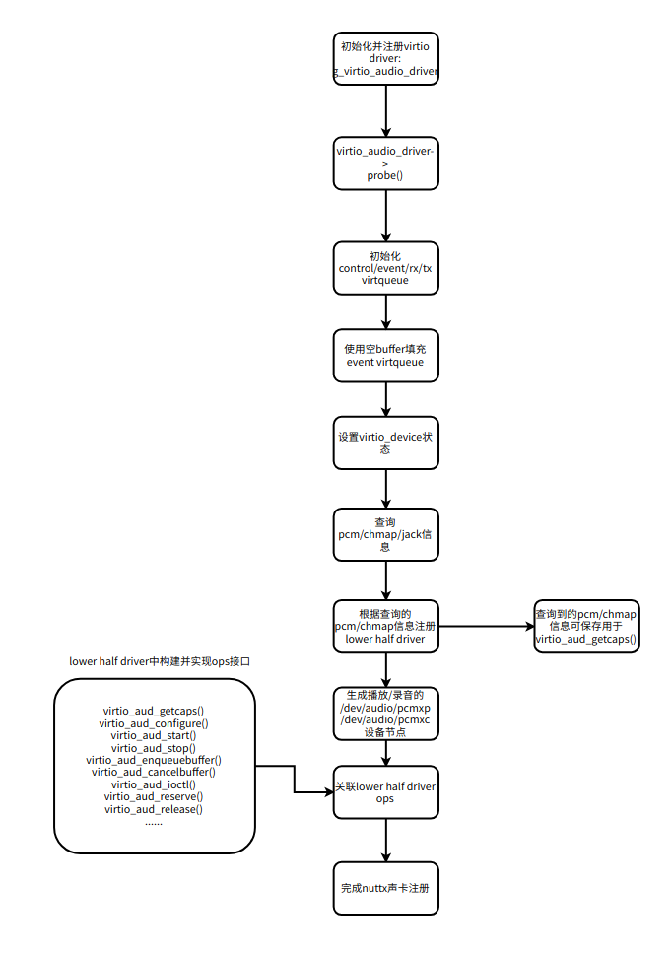

实现audio ctrl msg接口用于控制音频流

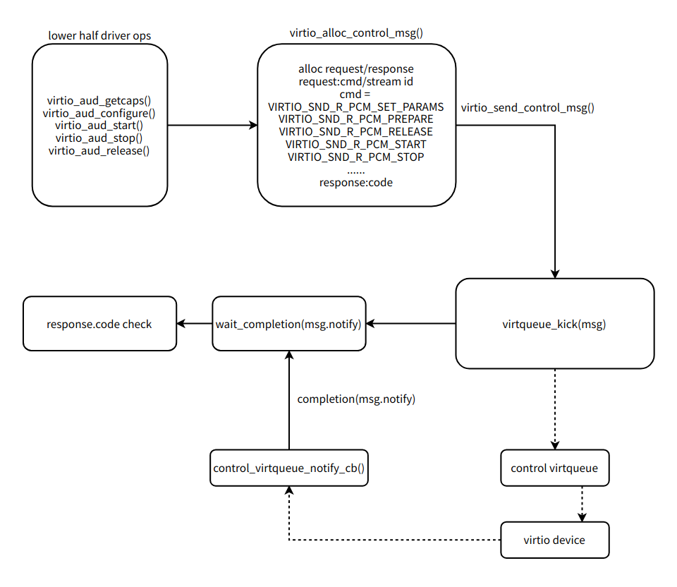

实现audio pcm msg传输接口用于录音/播放的pcm数据传输。

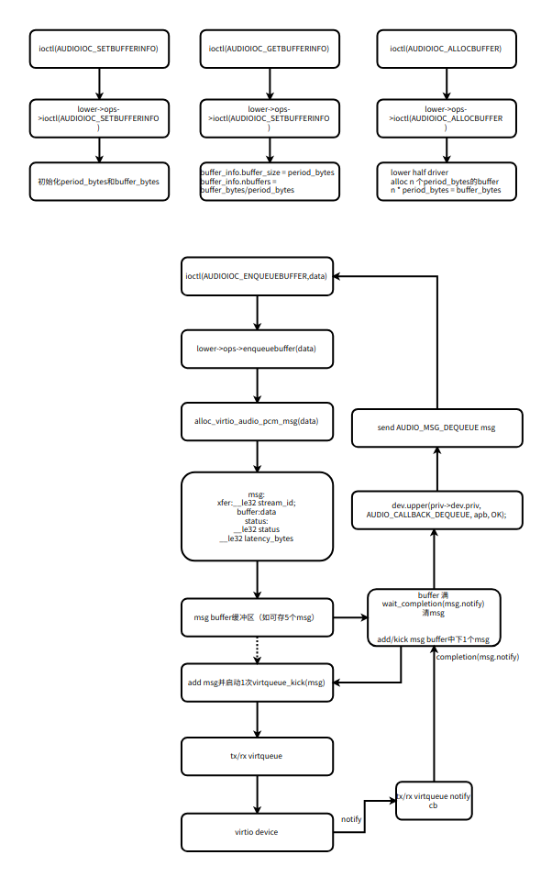

QEMU上的配置和使用参考[Audio](https://xiaomi.f.mioffice.cn/wiki/wikk4fA5TJrYWMcQqbe7qYMEJ6b)，驱动架构参考[Audio](https://xiaomi.f.mioffice.cn/wiki/wikk4Hikak0x5SnQNPNmUkaEx8f)。